Estimate Image Information (cutting die and print card):

Cutting Die Image:
Our normal box design which transfers from our corrugated style file may be replaced with a cad JPG image via the CAD# field on our SPEC folder of estimating. The N-K-1 control parameter called CADFILE will store the images on your server.

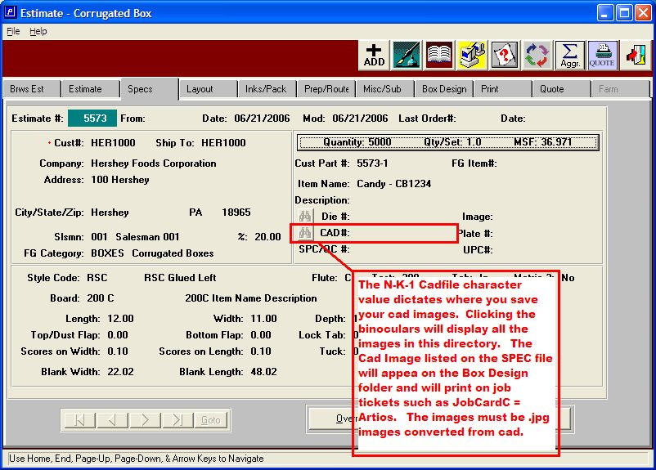

To assign a CAD image, CLICK THE Binocular and the images will display for selection. Please note that I have opted to add separate files for each customer so that I can retrieve images specific to each customer. This is not required, but recommended.
Also, when renaming the cad image to a .JPG or .BMT or .PDF file, we recommend using the estimate number or customer part number as the file number as an easy way to recall the image.

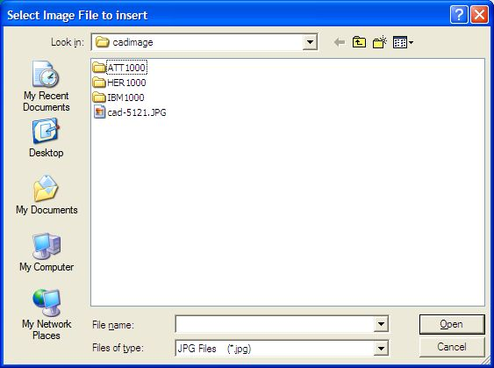

N-K-1 CADFILE
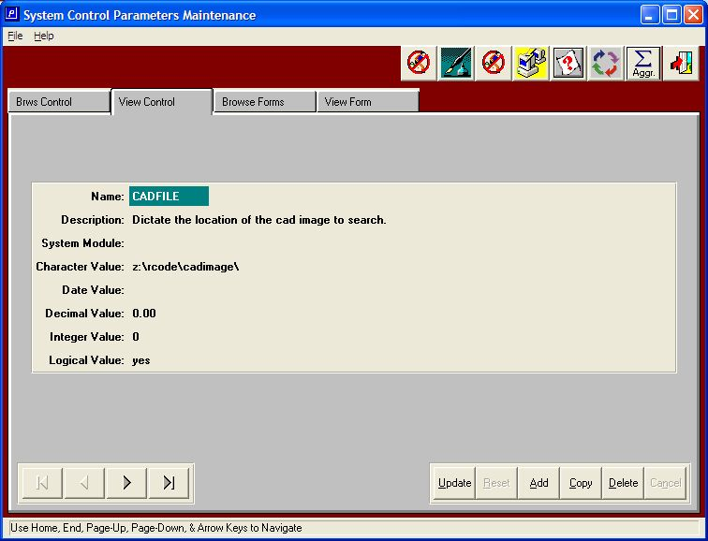
CAD-CAM FILE LOCATION
The character value indicates the folder / directory that the cad images are stored. The images must be .jpg or .bmp images (we recommend .jpg). From the corrugated estimate SPEC folder, pressing F1 on the CAD#, the file name of the image is selected; the die / cad image will transfer to the BOX DESIGN folder and overwrite the original image. This image will print on the corrugated job ticket such as the Artios factory ticket as a separate page. Please note, N-K-DIEFILE points to the Folding Estimate Binocular ICON next to the Die#. (The “Die #” binoculars are not used in the corrugated package).

Print Card Image
If you also want to have a print card image you would need to attach the image to the FG item related to the estimate. To do this you would need to complete the estimate and either key in a FG item number on the “Estimate” tab (this is sometimes done when a new system is being installed and a user wants to maintain existing FG item numbers) – or, you can let the system assign an inventory item number during the order entry process. (See review the options for the NK1 parameters called FGITEM# to see the options on the auto creation of inventory item numbers during the order entry process.) One there is a FG Item number associated with the estimate you can then add a print card image (which will print on a factory ticket, such as the Artios version).
Once there is a FG Item number associated with the estimate, you can add the image path in either the FG File (I-F-1 then the “Image Tab” for the specific FG item).
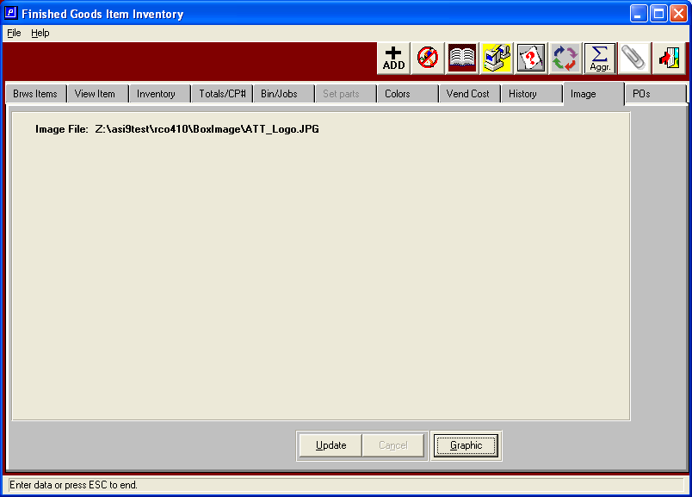

Or you can enter the path from the “Graphics” button on the box design tab of the estimate (again, only after the FG item number has been associated with the estimate).

